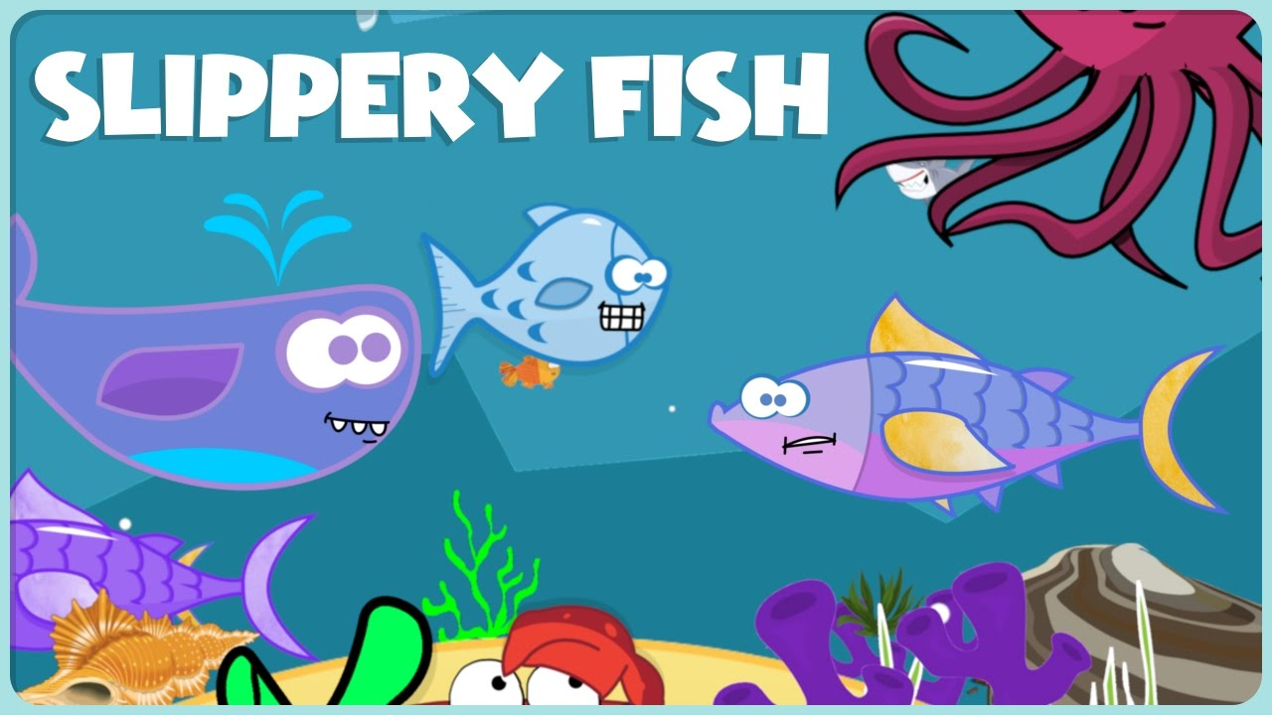

**SLIPPERY FISH SEQUENCE**

|  |  |  |  |  |
| --- | --- | --- | --- | --- |
| 1 | 2 | 3 | 4 | 5 |

--------------------------------------------------------------------------------------

|  |  |  |  |  |
| --- | --- | --- | --- | --- |
|  |  | Resultado de imagen para OCTOPUS FOR COLORING |  | Resultado de imagen para TUNA fish FOR COLORING |